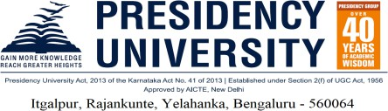
Presidency University, Bangalore
School of Engineering

Letter of Undertaking for Workshop Visit given by Parents/Guardian
Date: 25.03.2026
To,
The Dean,
School of Engineering, Presidency University, Bengaluru
Dear Sir,

Subject: Submission of “Workshop Visit Undertaking Letter by Parents”.

We, Mr. and Mrs. parents of bearing Register number , studying in / Semester, Department of Mechanical Engineering in School of Engineering, Bengaluru here with voluntarily submit the undertaking.
We, the undersigned parents/guardians, are aware that, our son/daughter is participating in the workshop visit organized by the institute on 25.03.2026 (Wednesday) to “SAE SUPRA WORKSHOP 2026”, We are voluntarily sending our ward for the aforementioned visit.

We shall ensure that our son/daughter shall abide by the university's terms and conditions for the workshop visit. We shall also ensure that our ward maintains discipline and decorum during the visit and shall uphold the prestige of the university. We hereby declare and confirm that the university shall not be held responsible in the event of any misfortune or accidents and/or personal injuries, whether fatal or otherwise, involving our son or daughter.

We further confirm that the university shall not be held responsible for our son or daughter's misconduct or wrong doing at all times during the period of workshop tour and shall obey the instructions of the faculty members who are accompanying them during the industrial tour.
Time Schedule is as follows. University Leaving Date: 25/03/2026 University Return Date: 26/03/2026

Note: The University will provide transportation facilities up to the “SAE SUPRA WORKSHOP 2026”, After the visit, students will be dropped back to the university campus from where they have to travel back on their arrangements to their residences.
Contact Phone No:

Contact Address:

Yours sincerely,

(Parents/Guardian’s Signature) Signature of the student Name: Name:

